**Assignment 18.1**

**Run a map only job on the word count program using static configurations**

It can be done statically by using set num reduce tasks

**DRIVER:**

In Driver class as it is a map only job set num reduce tasks to zero

Then set output file format as Sequence Output File format.

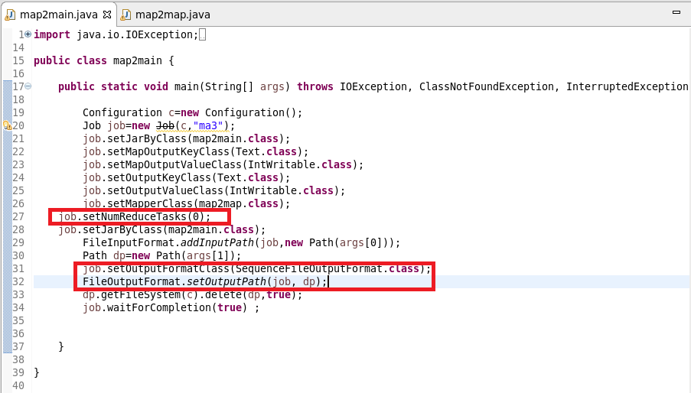

**MAPPER CLASS:**

In mapper class I have used a hashmap and updated it in such a way that if the word repeats I will increase the count by 1 and put it in hash map or else give a value of 1

**Cleanup Method:** I will override the clean method and write the final key and value instead of writing in mapper as mapper will be invoked for each line.

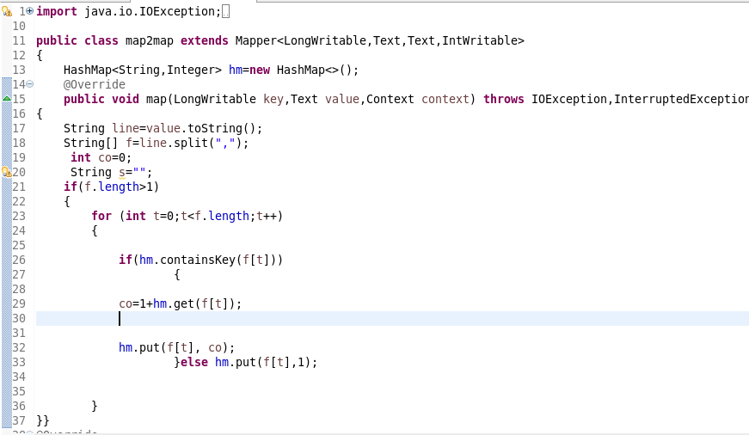

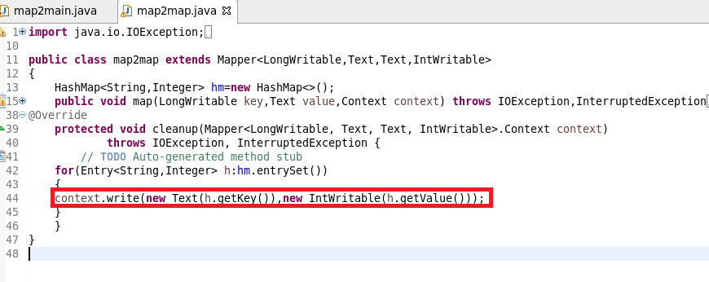

**RUNNING JAR:**

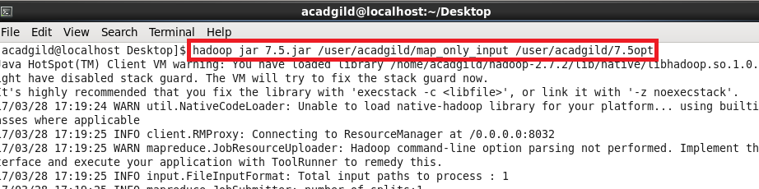

**OUTPUT:**

**USED text COMMAND TO OPEN SEQUENCE FILE:**

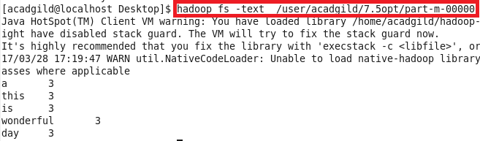

**Run the mapreduce word count program and set the number of reducers to 2 using static configurations**

**Driver:**

Here We can use SetNumReduceTasks(2)

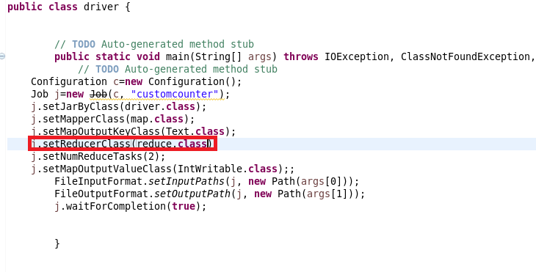

**Mapper:**

Send the words as key and for each key I will sent 1 as value. So that a count could be made in reducer

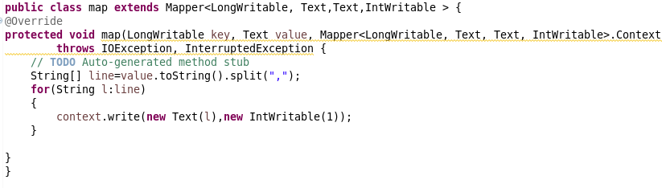**Reducer:**

Made a count of Words

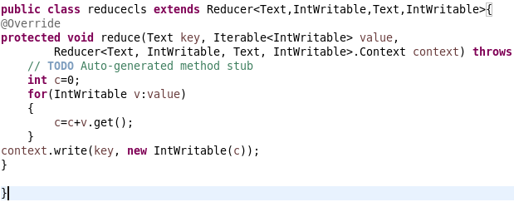

**Running Jar:**

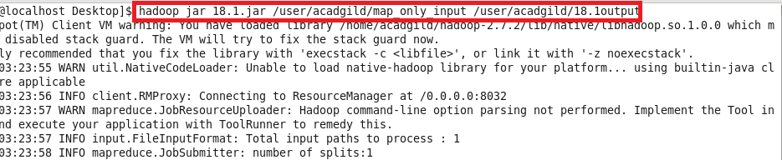

**Output:**

